Part B- Micro-project Proposal

Title :- Food Ordering and Generating Bill

**1.0 Rationale:**

This are Food Ordering and Generating Bill using Java will allow the user to record items that are being purchased by the customer. "Online are Food Ordering and Generating Bill " is a web application. This system is developed to automate day to day activity of a restaurant. Restaurant is a kind of business that serves people all over world with ready made food.

This system is developed to provide service facility to restaurant and also to the customer. This restaurant management system can be used by employees in a restaurant to handle the clients, their orders and can help them easily find free tables or place orders.

The services that are provided is food ordering and reservation table management by the customer through the system online, customer information management and waiter information management, menu information management and report.

The restaurant menu is organized by categories (appetizers, soups, salads, entrees, sides and drinks) of menu items. Main objective build the system this is to provide ordering and reservation service by online to the customer. Each menu item has a name, price and associated recipe. A recipe for a menu item has a chef, preparation instruction sand associated ingredients. With this system online, ordering and reservation management will become easier and systematic to replace traditional system where are still using paper. To resister a meal online, the customer has to become a member first then he can access the later part of the site. this project to facilitate customer for make online ordering and reservation. The option of becoming member was only an attempt to avoid (to some extent) placing the fake bookings. Online are Food Ordering and Generating Bill is the system for manage the restaurant business.

After successful login the customer can access the menu page with the items listed according to the desired time. The main point of developing this system is to help restaurant administrator manage the restaurant business and help customer for online ordering and reserve table. In proposed system user can search for a menu according to his choice i.e. according to price range and category of food and later he can order a meal.

**2.0 Aims/Benefits of the Micro-Project :-**

This Micro project aims at :

This Micro-project aims are **Food Ordering and Generating Bill** helps the restaurant to manage the restaurant more effectively and efficiently by computerizing meal ordering, billing and inventory control.

* 1. **Course Outcomes Addressed :-**
     + **Develop java programs using classes and objects.**

**4.0 Actual Methodology Followed :-**

We have planned the micro-project on **“Food Ordering and Generating Bill”** under the guidance of subject teacher. Then our team collected information related to are Food Ordering and Generating Bill from syllabus book as well reference book. We took the reference from other website that are available on internet. We studied about the different components of are Food Ordering and Generating Bill such as button, textbox, color dialog, track bar, timer etc. Then we collected different toolbox related to are Food Ordering and Generating Bill. After the studied of one week, we designed a are Food Ordering and Generating Bill. Then we have finalized the project and prepared report on this micro-project.

**5.0 Actual Resources Used :-**

| **Sr.no** | **Name of**  **resources/materials** | **Specification** | **Qty** | **Remarks** |
| --- | --- | --- | --- | --- |
| 1 | Operating system | Windows 10 | 1 |  |
| 2 | Notepad++/Notepad |  | 1 |  |
| 3 | Laptop | Lenovo | 1 |  |
| 4 | Processor | I5 10th Generation | 1 |  |
| 5 | RAM | 4GB | 1 |  |

**6.0 Outputs of the Micro-Projects :- Code :**

**import java.util.*;**

**class Welcome**

**{**

**void Menu()**

**{**

**System.out.println();**

**System.out.println("****** Welcome to the Multi Cuisine Restaurant *****");**

**System.out.println("Starter Corner:\t\t1");**

**System.out.println("Main Course:\t\t2");**

**System.out.println("Deserts:\t\t3");**

**System.out.println();**

**System.out.println("Press 1 for Starter:");**

**System.out.println("Press 2 for Main Course:");**

**System.out.println("Press 3 for Cool with Deserts:");**

**System.out.println();**

**}**

**}**

**public class RestaurantManagement extends Welcome**

**{ //opening of class**

**public static void main(String args[])**

**{ //opening of main()**

**Scanner in= new Scanner (System.in);**

**int vstr,tvstr=0,nvstr,tnvstr=0,vfd,tvfd=0,nvfd,tnvfd=0,fd,tfd=0,amt=0,tamt=0,totalamt=0,d,totald=0,damt=0,ch;**

**double vat=0;**

**String str=" ",ans,choice="Y";**

**RestaurantManagement w=new RestaurantManagement();**

**w.Menu();**

**System.out.println("Enter Your Choice: ");**

**ch=in.nextInt();**

**switch(ch)**

**{ //opening of switch case**

**case 1:**

**System.out.println("!!!!!!!!!!!!!! Welcome to Starter Menu !!!!!!!!!!!!");**

**System.out.println("Enter 'VS' for Veg Starter and 'NVS' for Non-Veg Starter");**

**str=in.next();**

**if(str.equalsIgnoreCase("VS"))**

**{ //opening of 1st if**

**System.out.println(); System.out.println("Starter:\t\t\t\t\tPrice in Rs.");**

**System.out.println("1.Paneer Tikka\t\t\t\t\t110");**

**System.out.println("2.Veg Seekh Kebab\t\t\t\t110 ");**

**System.out.println("3.Hara Bhara Kebab\t\t\t\t110 ");**

**System.out.println("4.Shanghai Spring Roll\t\t\t\t150 ");**

**System.out.println("5.American Corn Ball\t\t\t\t150 ");**

**System.out.println("6.Cripsy American Corn\t\t\t\t140 ");**

**System.out.println("7.Cripsy Baby Corn\t\t\t\t140 ");**

**System.out.println("8.Cripsy Mushroom\t\t\t\t120");**

**System.out.println("9.Cripsy Chilly Potato\t\t\t\t120 ");**

**System.out.println("10.Cripsy Chilly Chana\t\t\t\t150 ");**

**System.out.println();**

**while(choice.equalsIgnoreCase("Y"))**

**{ //opening of while**

**System.out.println("Choose your starter from the above list by entering number:");**

**vstr=in.nextInt();**

**System.out.println("Enter the total number of starter you want:");**

**tvstr=in.nextInt();**

**if(vstr>=1 && vstr<=3)**

**amt=tvstr*110;**

**if(vstr==4 || vstr==5)**

**amt=tvstr*150;**

**if(vstr==6 || vstr==7)**

**amt=tvstr*140;**

**if(vstr==8 || vstr==9)**

**amt=tvstr*120;**

**if(vstr==10)**

**amt=tvstr*150;**

**tamt=tamt+amt;**

**System.out.println("Do you want to place more order? Enter Y/N");**

**choice=in.next();**

**} //end of while**

**} //end of 1st if**

**if(str.equalsIgnoreCase("NVS"))**

**{ //opening of 2nd if**

**System.out.println("**** Non-Vegetarian Starter ****");**

**System.out.println();**

**System.out.println("Non-Vegetarian Starter\t\t\tPrice in Rs.");**

**System.out.println("1.Chicken Tikka\t\t\t\t170");**

**System.out.println("2.Murg Reshmi Kebab\t\t\t170 ");**

**System.out.println("3.Murg Chilli Kebab\t\t\t160 ");**

**System.out.println("4.Chicken Seekh Kabab\t\t\t180 ");**

**System.out.println("5.Tangdi Kebab\t\t\t\t180 ");**

**System.out.println("6.Murg Tandoori\t\t\t\t190 ");**

**System.out.println("7.Fish Ajwani Tikka\t\t\t190 ");**

**System.out.println("8.Chilli Chicken\t\t\t160 ");**

**System.out.println("9.Drums of Heaven\t\t\t180 ");**

**System.out.println("10.Shanghai Chicken\t\t\t180 ");**

**System.out.println();**

**while(choice.equalsIgnoreCase("Y"))**

**{ //opening of while**

**System.out.println("Choose your starter from the above list by entering number:");**

**nvstr=in.nextInt();**

**System.out.println("Enter the total number of starter you want:");**

**tnvstr=in.nextInt();**

**if(nvstr==1 || nvstr==2)**

**amt=tnvstr*170;**

**if(nvstr==3)**

**amt=tnvstr*160;**

**if(nvstr==4 || nvstr==5)**

**amt=tnvstr*180;**

**if(nvstr==6 || nvstr==7)**

**amt=tnvstr*190;**

**if(nvstr==8)**

**amt=tnvstr*160;**

**if(nvstr==9 || nvstr==10)**

**amt=tnvstr*180;**

**tamt=tamt+amt;**

**System.out.println("Do you want to place more order? Enter Y/N");**

**choice=in.next();**

**} //end of while**

**} //end of 2nd if**

**System.out.println("*** Multi Cuisine Restaurant ***");**

**System.out.println("****** BILL ******");**

**System.out.println("Total cost= Rs."+tamt);**

**vat=Math.round(14.5/100.0*tamt);**

**System.out.println("VAT = 14.5 %");**

**System.out.println("Total VAT = Rs."+vat);**

**System.out.println("Amount to be paid= Rs."+(tamt+vat));**

**System.out.println();**

**break;**

**case 2:**

**System.out.println("******* Main course of Indian and chinese dishes *******");**

**System.out.println("Enter 'V' for Indian Veg Dishes,'NV' for Indian Non-Veg Dishes and 'C' for Chinese Dishes");**

**str=in.next();**

**//opening of 1st if**

**if(str.equalsIgnoreCase("V"))**

**{**

**System.out.println("!!!!!!!!!!!! Welcome to Indian Veg Dishes !!!!!!!!!!!!");**

**System.out.println();**

**System.out.println("Indian Veg dishes\t\t\t\tPrice in Rs.");**

**System.out.println("1.Shahi Paneer\t\t\t\t\t180");**

**System.out.println("2.Navratan Korma\t\t\t\t180");**

**System.out.println("3.Kadahi Paneer\t\t\t\t\t150");**

**System.out.println("4.Malai Kofta\t\t\t\t\t180");**

**System.out.println("5.Kadahi Vegetable\t\t\t\t140");**

**System.out.println("6.Vegetable Pikeeza\t\t\t\t140");**

**System.out.println("7.Shabnam Curry\t\t\t\t\t150");**

**System.out.println("8.Makai Corn Palak\t\t\t\t150");**

**System.out.println("9.Veg.Pulao\t\t\t\t\t110");**

**System.out.println("10.Kashmiri Pulao\t\t\t\t140");**

**System.out.println("11.Butter Naan\t\t\t\t\t40");**

**System.out.println("12.Stuffed kulcha\t\t\t\t60");**

**System.out.println();**

**//opening of while**

**while(choice.equalsIgnoreCase("Y"))**

**{**

**System.out.println("Choose your Main Veg Course form the list by entering number: ");**

**vfd=in.nextInt();**

**System.out.println("How many plates do you want to place from the above list ?");**

**tvfd=in.nextInt();**

**if(vfd==1 || vfd==2)**

**amt=tvfd*180;**

**if(vfd==3)**

**amt=tvfd*150;**

**if(vfd==4 || vfd==5 || vfd==6)**

**amt=tvfd*140;**

**if(vfd==7 || vfd==8)**

**amt=tvfd*150;**

**if(vfd==9)**

**amt=tvfd*110;**

**if(vfd==10)**

**amt=tvfd*140;**

**if(vfd==11)**

**amt=tvfd*40;**

**if(vfd==12)**

**amt=tvfd*60;**

**totalamt=totalamt+amt;**

**System.out.println("Do you want to place more order? Enter Y/N");**

**choice=in.next();**

**}**

**if(str.equalsIgnoreCase("NV"))**

**{**

**System.out.println();**

**System.out.println("!!!!!!!!!! Welcome to Indian Non-Veg Dishes !!!!!!!!!!");**

**System.out.println();**

**System.out.println("Indian Non-Veg dishes:\t\tPrice in Rs.");**

**System.out.println("1.Chicken Tikka Masala\t\t\t180");**

**System.out.println("2.Chhicken Tikka Labadar\t\t180");**

**System.out.println("3.Chicken Bharta\t\t\t150");**

**System.out.println("4.Kadahi Chicken\t\t\t160");**

**System.out.println("5.Mughlai Chicken\t\t\t160");**

**System.out.println("6.Murg Navratan Korma\t\t\t160");**

**System.out.println("7.Chicken Do Pyaza\t\t\t170");**

**System.out.println("8.Murn Masallam\t\t\t\t170");**

**System.out.println("9.Mutto Rogan Josh\t\t\t110");**

**System.out.println("10.Prawn Malai Curry\t\t\t190");**

**System.out.println("11.Fish Sarsowala\t\t\t40");**

**System.out.println("12.Fish Dhaniawala\t\t\t60");**

**System.out.println();**

**while(choice.equalsIgnoreCase("Y"))**

**{**

**System.out.println("Choose your Main Non-Veg Course form the list by entering number: ");**

**nvfd=in.nextInt();**

**System.out.println("How many plates do you want to place from the above list ?");**

**tnvfd=in.nextInt();**

**if(nvfd==1 || nvfd==2)**

**amt=tnvfd*180;**

**if(nvfd==3)**

**amt=tnvfd*150;**

**if(nvfd==4 || nvfd==5 || nvfd==6)**

**amt=tnvfd*160;**

**if(nvfd==7 || nvfd==8)**

**amt=tnvfd*170;**

**if(nvfd==9 || nvfd==10)**

**amt=tnvfd*190;**

**if(nvfd==11)**

**amt=tnvfd*140;**

**if(nvfd==12)**

**amt=tnvfd*160;**

**totalamt=totalamt+amt;**

**System.out.println("Do you want to place more order? Enter Y/N");**

**choice=in.next();**

**}**

**}**

**if(str.equalsIgnoreCase("C"))**

**{**

**System.out.println("!!!!!!!!!!!! Welcome to Chinese Dishes !!!!!!!!!!!!!!");**

**System.out.println();**

**System.out.println("Chinise dishes:\t\t\t\tPrice in Rs.");**

**System.out.println("1.Schezwan Fried Rice\t\t\t\t240");**

**System.out.println("2.Schezwan Chicken\t\t\t\t280");**

**System.out.println("3.Chilly Chicken\t\t\t\t280");**

**System.out.println("4.Chicken Noodle\t\t\t\t210");**

**System.out.println("5.Veg. Hakka Noodle\t\t\t\t210");**

**System.out.println("6.Chicken Manchurian\t\t\t\t190");**

**System.out.println("7.Paneer Manchurian\t\t\t\t190");**

**System.out.println("8.Chilly Paneer\t\t\t\t\t190");**

**System.out.println("9.Sanghai Fried Rice\t\t\t\t240");**

**System.out.println("10.Veg.Fried Rice\t\t\t\t210");**

**System.out.println("11.Chicken Fried Rice\t\t\t\t210");**

**System.out.println("12.Kimchi Rice Veg\t\t\t\t210");**

**System.out.println();**

**while(choice.equalsIgnoreCase("Y"))**

**{**

**System.out.println("Choose your Main Course form the list by entering number: ");**

**fd=in.nextInt();**

**System.out.println("How many plates do you want to place from the above list ?");**

**tfd=in.nextInt();**

**if(fd==1)**

**amt=tfd*240;**

**if(fd==2 || fd==3)**

**amt=tfd*280;**

**if(fd==4 || fd==5)**

**amt=tfd*210;**

**if(fd==6 || fd==7 || fd==8)**

**amt=tfd*190;**

**if(fd==9)**

**amt=tfd*240;**

**if(fd==10 || fd==11 || fd==12)**

**amt=tfd*210;**

**totalamt=totalamt+amt;**

**System.out.println("Do you want to place more order? Enter Y/N");**

**choice=in.next();**

**}**

**}**

**}**

**System.out.println("*** Multi Cuisine Restaurant ***");**

**System.out.println("****** BILL ******");**

**System.out.println("Total cost= Rs."+totalamt);**

**vat=Math.round(14.5/100.0*totalamt);**

**System.out.println("VAT = 14.5 %");**

**System.out.println("Total VAT = Rs."+vat);**

**System.out.println("Amount to be paid= Rs."+(totalamt+vat));**

**System.out.println();**

**break;**

**case 3:**

**System.out.println("**** Cool with Deserts ***");**

**System.out.println();**

**System.out.println("Deserts:\t\t\t\tPrice in Rs.");**

**System.out.println("1.Softy Pineapple\t\t\t\t110");**

**System.out.println("2.Softy Crunchy Chocolate\t\t\t110");**

**System.out.println("3.Chocolate Walnut Brownie\t\t\t90");**

**System.out.println("4.Chocolate Doughnut\t\t\t\t90");**

**System.out.println("5.Marble Cake\t\t\t\t\t70");**

**System.out.println("6.Mocha Magic\t\t\t\t\t90");**

**System.out.println("7.Black Forest Gateaux\t\t\t\t90");**

**System.out.println("8.Mango Shake\t\t\t\t\t80");**

**System.out.println("9.Pineapple Shake\t\t\t\t80");**

**System.out.println("10.Tooty Fruity\t\t\t\t\t120");**

**System.out.println();**

**while(choice.equalsIgnoreCase("Y"))**

**{**

**System.out.println("Choose your desert by entering number: ");**

**d=in.nextInt();**

**System.out.println("Enter the total number of items you want to buy!!!"); totald=in.nextInt();**

**if(d==1 || d==2)**

**damt=totald*110;**

**if(d==3 || d==4)**

**damt=totald*90;**

**if(d==5)**

**damt=totald*70;**

**if(d==6 || d==7)**

**damt=totald*90;**

**if(d==8 || d==9)**

**damt=totald*80;**

**if(d==10)**

**damt=totald*120;**

**totalamt=totalamt+damt;**

**System.out.println("Do you want to place more order? Enter Y/N");**

**choice=in.next();**

**}**

**System.out.println();**

**System.out.println("*** Multi Cuisine Restaurant ***");**

**System.out.println("****** BILL ******"); System.out.println("Total cost= Rs."+totalamt);**

**vat=Math.round(14.5/100.0*totalamt);**

**System.out.println("VAT = 14.5 %");**

**System.out.println("Total VAT = Rs."+vat);**

**System.out.println("Amount to be paid= Rs."+(totalamt+vat));**

**break;**

**default:**

**System.out.println("You have entered wrong choice!!!");**

**System.out.println("You can enter in the Multi Cuisine Restaurant by executing the program again with the corrct choice");**

**System.out.println("Now,'quit' the program");**

**}**

**System.out.println("To exit Multi Cuisine Restaurant world, enter the word 'Quit'");**

**ans=in.next();**

**if(ans.equals("quit")||ans.equals("QUIT")||ans.equals("Q"))**

**{**

**System.out.println("Thanks for coming to Multi cuisine Restaurant");**

**System.out.println("your pleasure our comfort");**

**System.out.println("Visit Again");**

**System.out.println();**

**}**

**}**

**}**

**Output-**

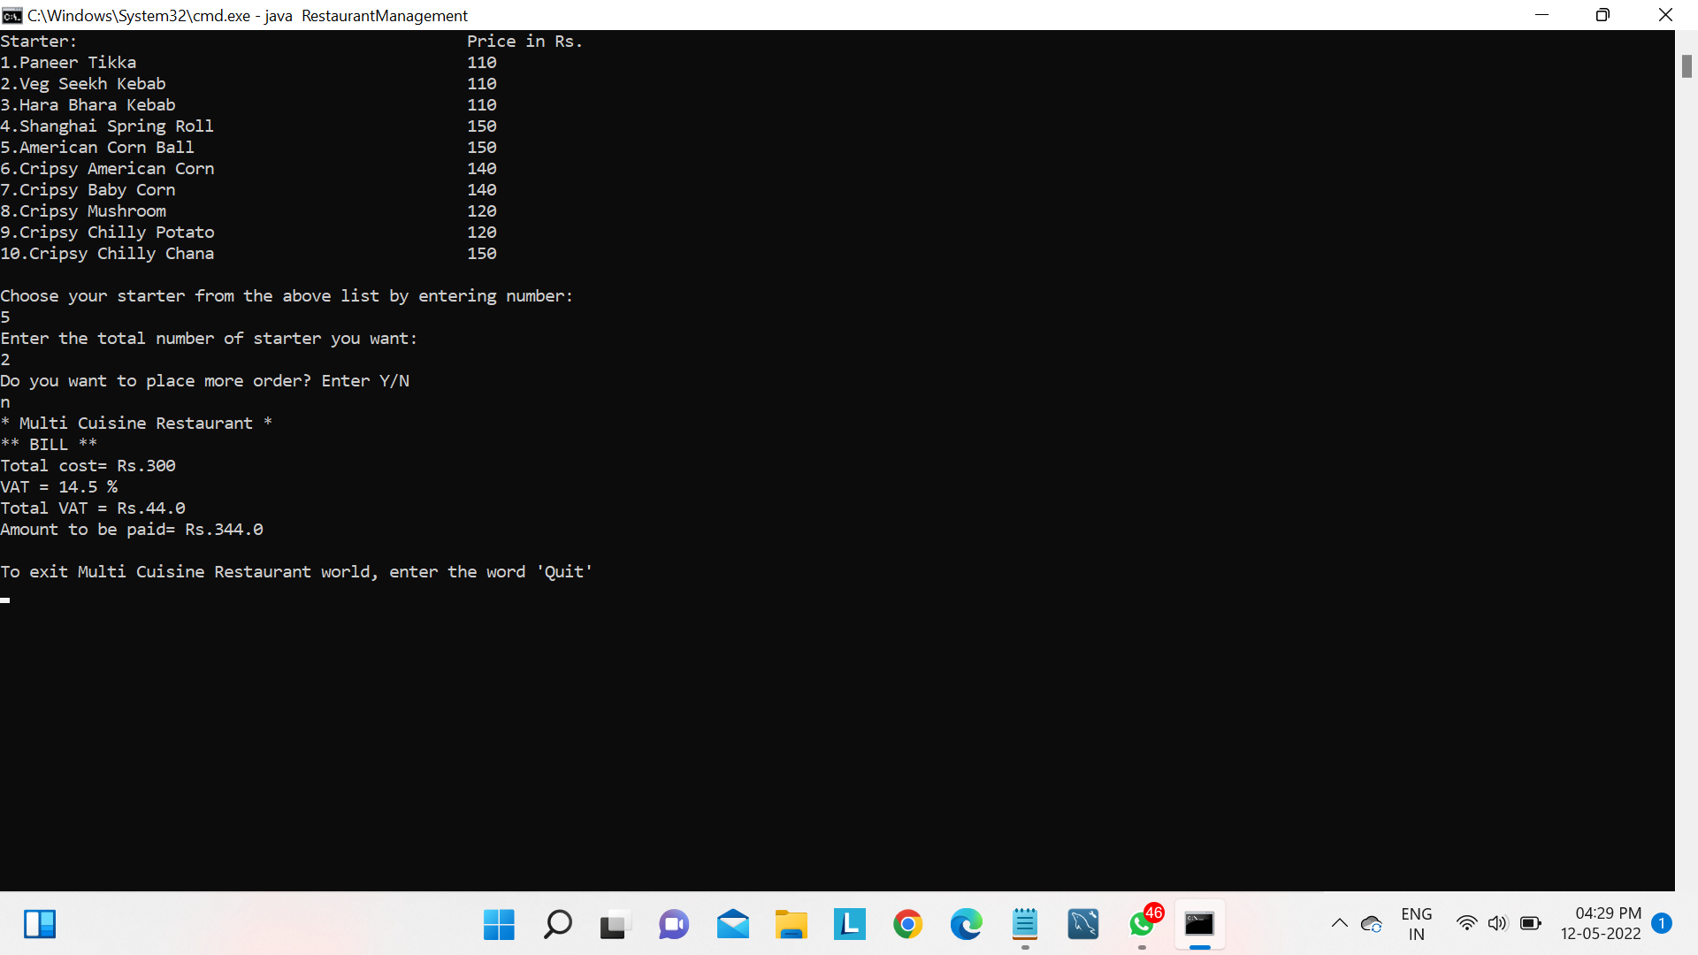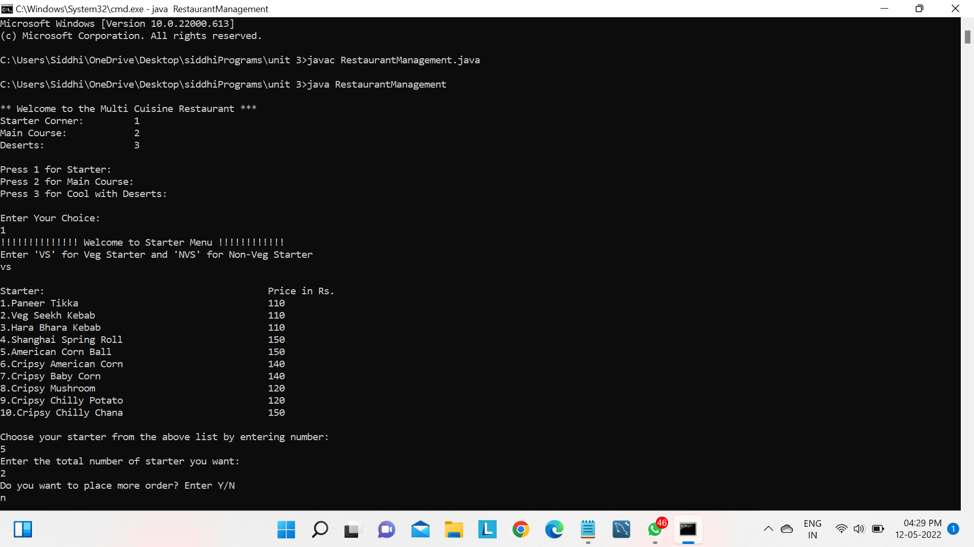

* 1. **Advantages:**
     + Quick and easy scheduling.
     + Reduce costs and stay on budget.
     + Keep on top if any issues with your staff.
     + Keep staff up-to-date.
     + Share staff between multiple locations.
  2. **Disadvantages:**
     + It is difficult for managers to supervise all the sides of restaurants like kitchen, floor, and counter simultaneously.
     + Many of the systems will not store the budget store details for a long time.

**9.0 Skill Developed / Learning outcome of this Micro-Project :-**

We have studied : Food Ordering and Generating Bill source code in android project download restaurant management application in this project many features. search restaurant by place. Customer info save. Order listing in apps. Today menu listing. This project final year major projects. Many features in this project. Like google map API using for display restaurant. User can search restaurant near by location. Download android application source code for student. Free download android source code.

* 1. **Applications of this Micro-Project :-**
     + The are Food Ordering and Generating Bill software you use is essential to your business’ success.
* Many owners and managers get caught up in the human aspect of management, but if the support software being utilized isn’t user-friendly, then it’s a disservice.

**11.0 Conclusion :**

The success of every major restaurant business chain lies in its operations and management. These tools will provide you with an opportunity to make your restaurant and life much easier. Not only will they help your restaurant expand, but will also make it more efficient at a lower cost.